**STUDENT PROJECT**

Programmers: BILL AND KAY

**Introduction**

Before we decided to choose a student project, I got an idea that we are students, so if we write the program for students, it will be a very useful tool for a student’s life. The concept for this project is that most international students are very lonely when they come to the United States. For example, when I (Kay) came to the U.S, I did not have any friends because of a language barrier. Therefore, I decided to join international ambassador groups, and I found some friends there. At that time, Bill told me that we should have a group class for our project. As per my experiences, I agreed with Bill’s idea.

**Planning**

After deciding to choose the Student Project, we started to sketch our program:

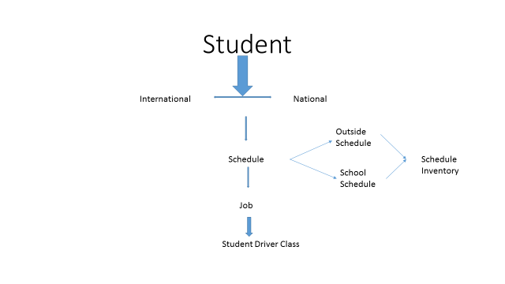

After that, we decided that we should add more classes because we felt like it was a very simple program. We discussed that as a programmer, we should have a good portfolio so that we could find a job easily. So we added **RESUME CLASS,** which includes student GPA and job history. Then, we added **GROUP CLASS**, which includes **AMBASSADOR CLASS**, **CSC CLASS**, and **STUDENT GOVERNMENT CLASS**. At that time, we did not have **Node class** because we could not figure out where we should add that class. However, finally, we could add this class (for tracking student GPA and how many jobs they have worked).

**Programming Process**

**Kay’s Challenges**

Before creating a resume class, I (Kay) did not know much about how an iterator works, so I looked it up online, and did exercises. Also, I read the section again. After that, although I did not understand very well about iterators, at least I understood how it works.

**Bill’s Challenges**

I did not understand where to use the ListNode, so I studied that again. At first I intended to use ListNode for Schedule, but I used it for GPA.

In addition, the first time, we agreed to do the graphic, but Kay (another Kay) said that she will do her own project. So, we canceled the graphic part.

**Prototype**

Student is the parent class for national and international classes. First, the program introduces how it works. After that, it offers to a user like this:

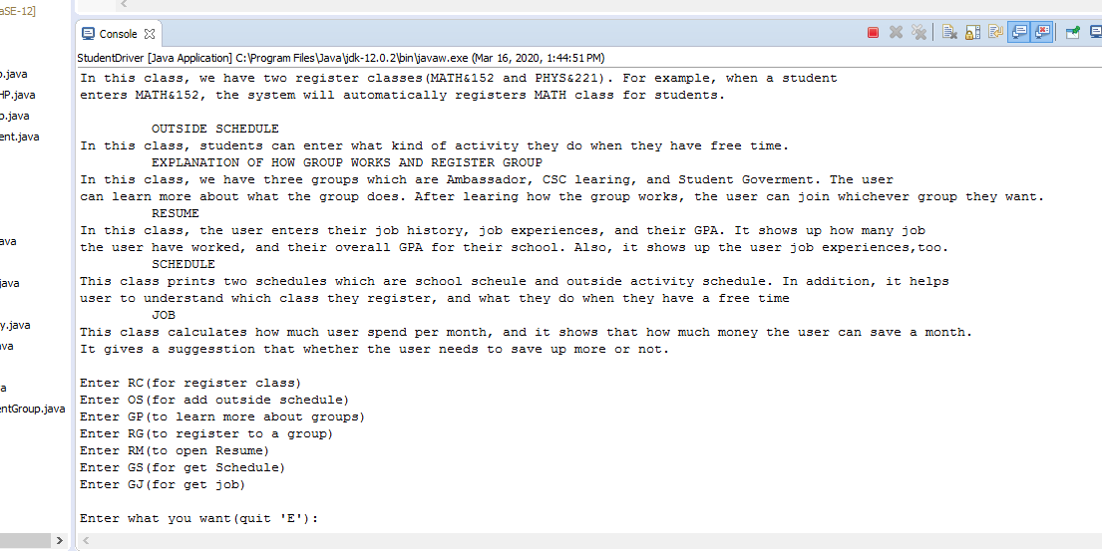

Then, the user can register their class and their group. Also, they can add their outside schedule, their resume, and their job. If we have time, we would do a graphic, and we would work on the data from the instructor than students.

**Lessons Learned**

We learned a lot from this process. First, after CSC 141, we did not understand very well about chapter 8 classes. However, while we were working on this project, we understood the classes, and also the array list. We feel that we understand the purpose and use of classes better now. However, we think that we need to study more about recursion and Linked List (Node) because we haven’t spent that much time studying these. In addition, we need to study more about hash tree too. Overall this course, we feel like we have learned much more about programming than we knew before.